|  |
| --- |
| **NATIONAL UNIVERSITY OF COMPUTER AND EMERGING SCIENCES**  **CS 201–DATA STRUCTURES LAB**  **Lab Session 11** |
| **Instructors:** Mr. Faizan Yousuf, Ms. Safia, Ms. Maham Mobin |

**STACK**

A stack is a container of objects that are inserted and removed according to the last-in-ﬁrst-out (LIFO) Principle. Objects can be inserted at any time, but only the last (the most-recently inserted) object can be removed. Inserting an item is known as “pushing” onto the stack. “Popping” off the stack is synonymous with removing an item.

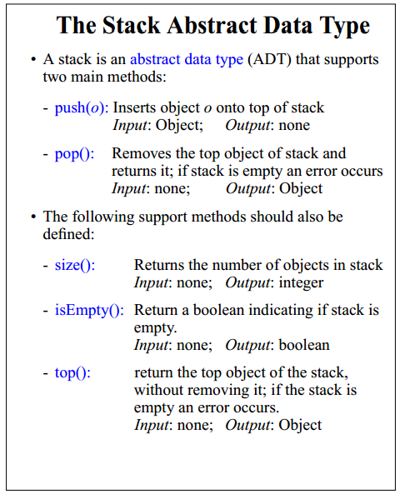

**Task1: Create a stack, Implement all functions**

**Queue:**

A queue is a particular kind of abstract or collection. In which its insertion and removal routines follows the ﬁrst-in-ﬁrst-out (FIFO) principle.

* First In First Out (FIFO).  Insertions at the "end" of the queue, and removals from the "front" of the queue.
* Analogy - waiting in line for a ride at an amusement park.  Get in line at the end.  First come, first serve.
* A queue class will have two primary operations:
  + **enqueue** -- Elements are inserted at the rear (i.e. at the back of the line)
  + **dequeue** -- removed from the front .
* Typical application areas include print job scheduling, operating systems (process scheduling).

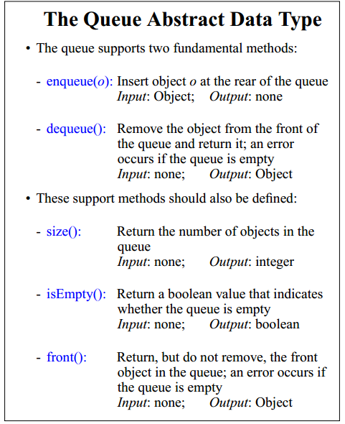

**Task1:**

1. **Create Queue and implement all functions.**
2. **Implement a queue which deletes all negative integers without changing the order of the remaining elements in the queue.**
3. **Implement function which reverses the content of queue.**